**Project 5: Bank Algorithm**

Hao Wu

5140219226

May 16, 2017

Instructor: Ling Gong

1. Object:

For this project, you will write a multithreaded program that implements the banker’s algorithm discussed in Section 7.5.3. Several customers request and release resources from the bank. The banker will grant a request only if it leaves the system in a safe state. A request that leaves the system in an unsafe state will be denied. This programming assignment combines three separate topics: (1) multithreading, (2) preventing race conditions, and (3) deadlock avoidance.

1. Screen Cut:

By typing the available source and initial situation of each customer in 1.txt, we can simulate the banker’s algorithm using multi-threading, preventing race conditions and deadlock avoidance. As figure1 shows, we can try to allocate source to one specific customer, if the allocation is reasonable, the console will return ”Approved”. Anytime customer obtains all source it needs, it will release all the source and quit. Besides, like figure2 shows, we can choose to let one customer release some source it occupies. The error processing are presents in figure3, any source allocation and release which beyond really needed or occupied will be denied.

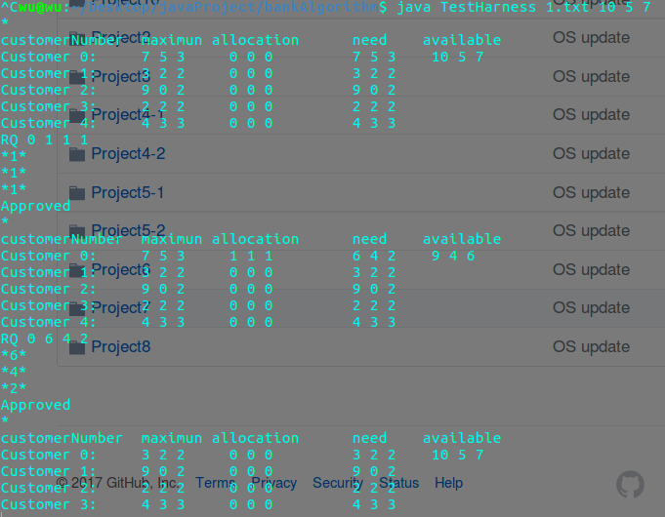

**Fig1 Ssources allocation**

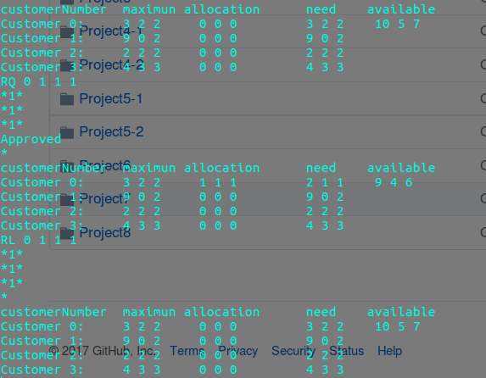

**Fig2 Sources Release**

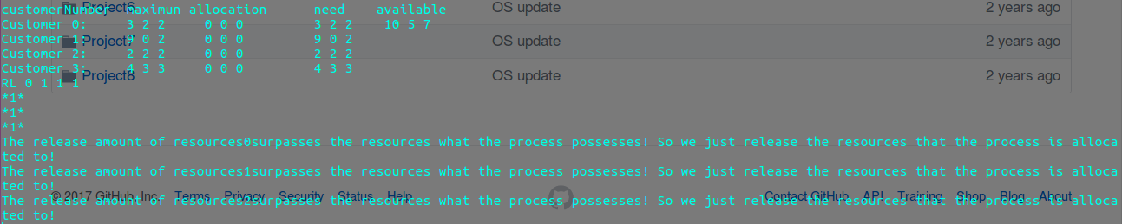

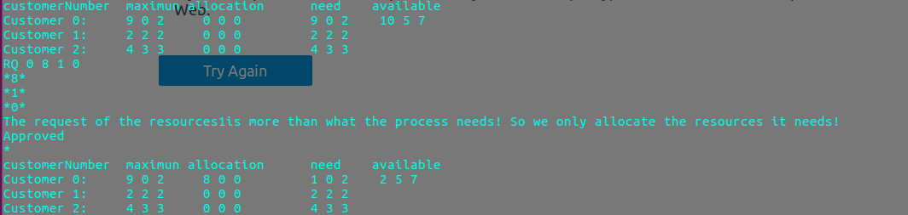

**Fig3 Error processing**